**Directory Structure of Spring MVC**

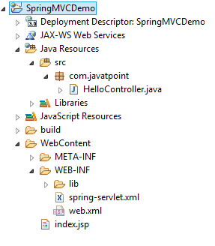

## Directory Structure of Spring MVC using Maven

